

Dr. Sarah, Sanchez inc.
2016-10-24
Dr. Sanchez
123 Stevens Well, Anitamouth, SD 19226
Phone: 6437278725
Fax: 7213094266

Re: Sophia, Rodriguez
PHN: 3852868857
Birthdate: 06-Oct-1959
Address: 78127 Rebecca Alley, Juliestad, MN 78589
Patient number: 4351505509

To Whom It May Concern:

This is a medical letter to state the above patient is pregnant with expected delivery date of 02-Feb-2025. Hoping this information is satisfactory for your requirements.

Thank you.

Sincerely,
Dr. Sarah, Sanchez
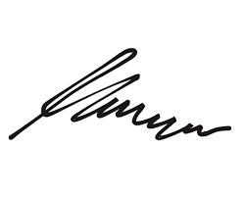
FRCS© NCMP
Clinical Assistant Professor, UBC
Department of Obstetrics and Gynecology SMH

